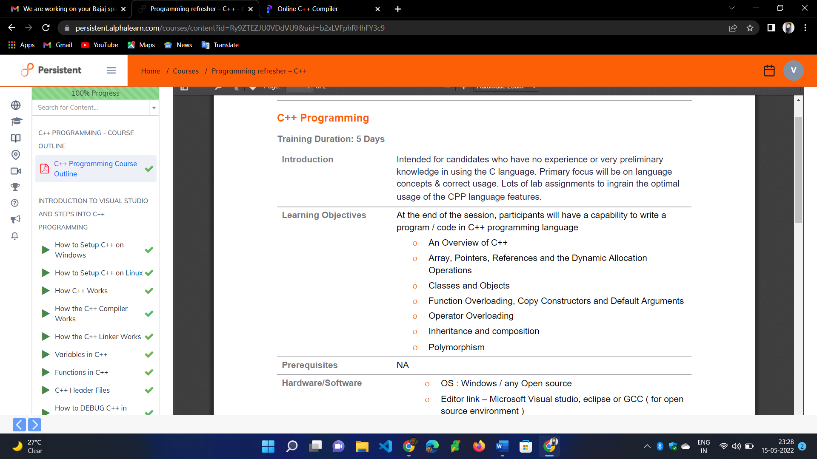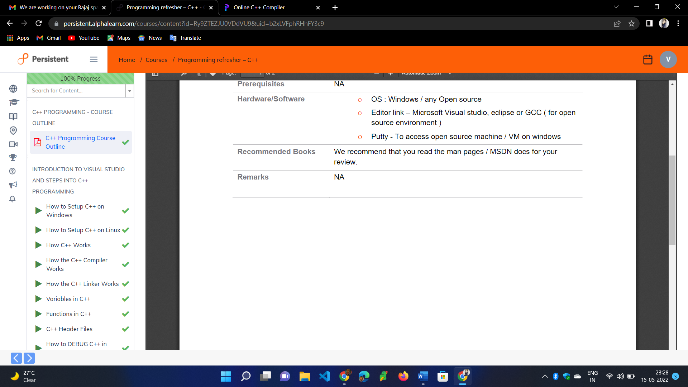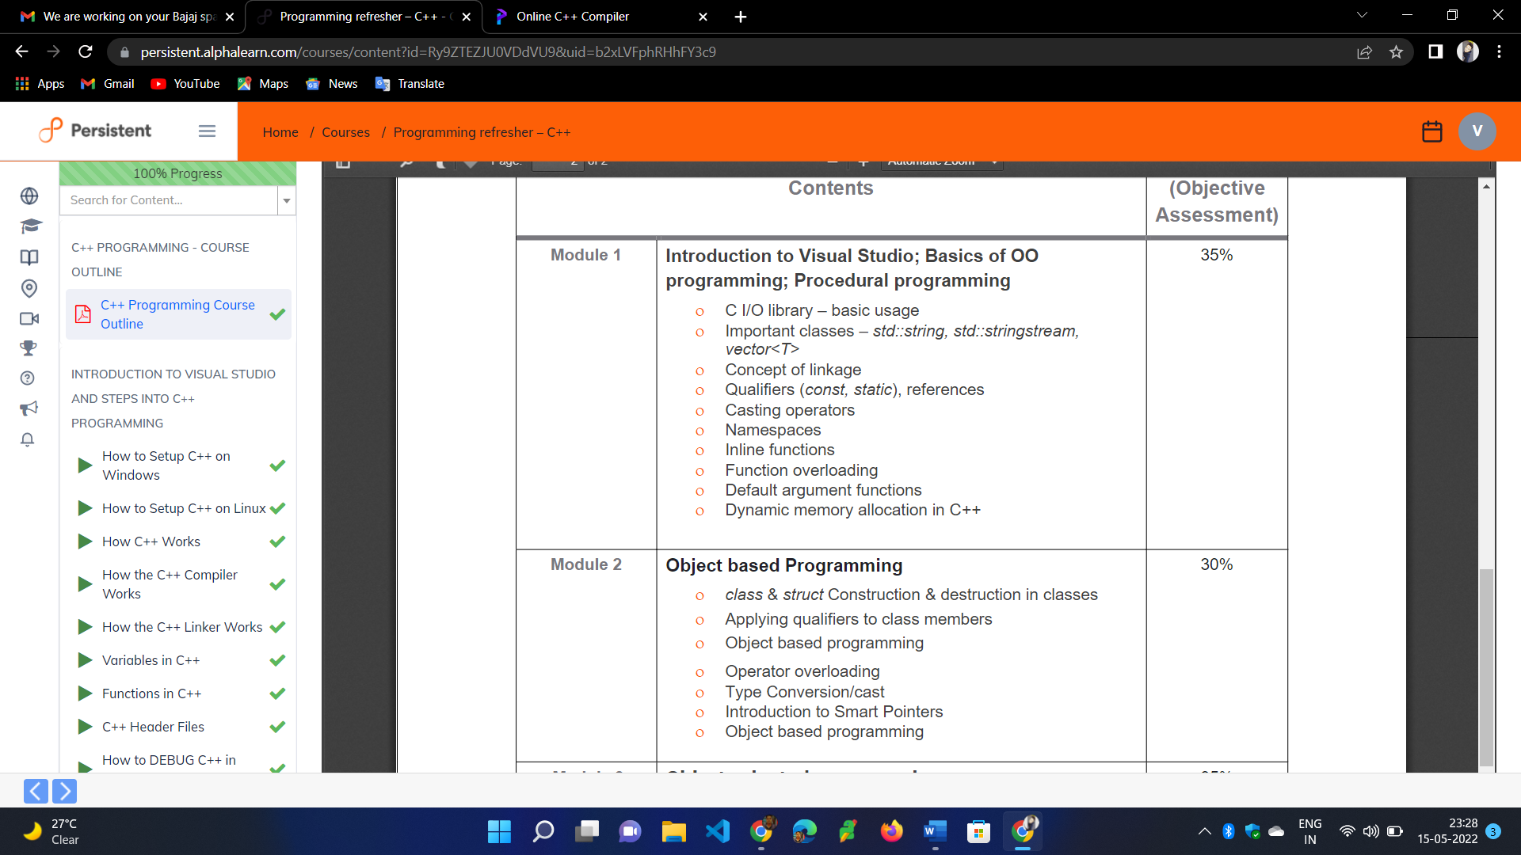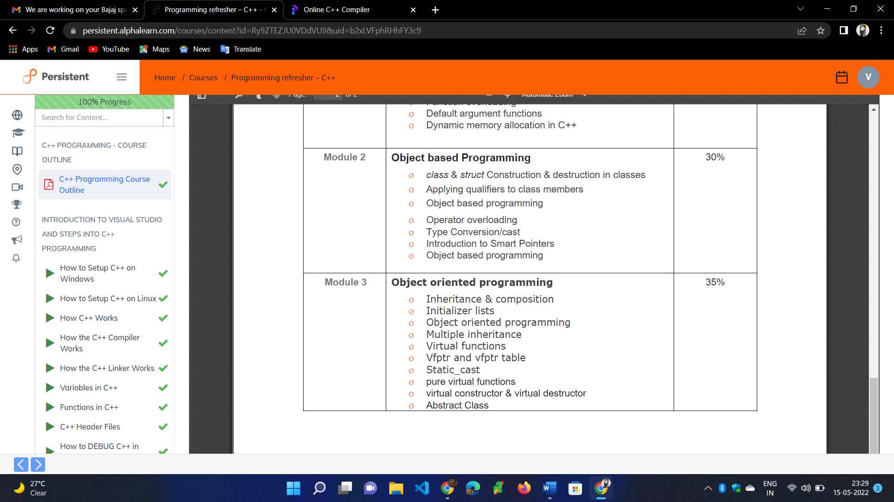

How to set up c++ on window

1. <https://youtu.be/1OsGXuNA5cc>

How to set up c++ on Linux

1. <https://youtu.be/LKLuvoY6U0I>

How C++ Works

1. <https://youtu.be/SfGuIVzE_Os>

How the c++ Compiler Works

1. <https://youtu.be/3tIqpEmWMLI>

How the c++ Linker Works

1. <https://youtu.be/H4s55GgAg0I>

Variables in c++

1. <https://youtu.be/zB9RI8_wExo>

Functions in c++

1. <https://youtu.be/V9zuox47zr0>

C++ Header Files

1. <https://youtu.be/9RJTQmK0YPI>

How to DEBUG C++ in VISUAL STUDIO

1. <https://youtu.be/0ebzPwixrJA>

BEST Visual Studio Setup for C++ Projects!

1. <https://youtu.be/qeH9Xv_90KM>

POINTERS in C++

1. <https://youtu.be/DTxHyVn0ODg>

# REFERENCES in C++

1. <https://youtu.be/IzoFn3dfsPA>

**Introduction to CPP Functions**

1. <https://youtu.be/4bgabzer4OE>

# C++ Default Function Parameters

1. <https://youtu.be/QHk_hg5NOU4>

# C++ Inline Function

1. <https://youtu.be/TGwl3tJYFRg>

# C++ Local Global Variable Scopes

1. <https://youtu.be/kMdoS47ySjs>

# New and Delete Operators in C++

1. <https://youtu.be/gVGnOsB1n_o>

# Dynamically Allocating Arrays Depending on User Input in C++

1. <https://youtu.be/8XAQzcJvOHk>

# Introduction to Strings in C++

1. <https://youtu.be/3-v_RigflHs>

# Function Overloading in C++

1. <https://youtu.be/wQEByoBQG-o>

**CLASSES in C++**

1. <https://youtu.be/2BP8NhxjrO0>

**CLASSES vs STRUCTS in C++**

1. <https://youtu.be/fLgTtaqqJp0>

How to Write a C++ Class

1. <https://youtu.be/3dHBFBw13E0>

Creating Objects from a Class in Different Ways

1. <https://youtu.be/BsYvWqDihGU>

Scope Resolution Operator | Defining Methods outside Class definition in C++

1. <https://youtu.be/59fy7la7yEI>

# Private Access Specifier

1. <https://youtu.be/6QHkXmLhY-g>

Class Constructors

1. <https://youtu.be/CyTSm0sUgi4>

**Overloading Class Constructors**

1. <https://youtu.be/bk11sI0KoWk>

**Default Class Constructor Parameters**

1. <https://youtu.be/0Gcy49Gin_k>

Destructors in a Class

1. <https://youtu.be/Egm6DIiHTC4>

C++ Destructors to Release Resources with example

1. <https://youtu.be/ZvWUHWvueQk>

C++ Static Variables and Members in Class

1. <https://youtu.be/-WRllQLW8RE>

C++ Static Methods in Classes

1. <https://youtu.be/u-lQOQvzBuY>

Inheritance

1. <https://youtu.be/zsqhrxlp-Fo>

C++ Protected Access Modifier in Classes

1. <https://youtu.be/nW0hf2-jaIM>

C++ Access Control and Inheritance

1. <https://youtu.be/XRlo8aOUvyU>

Public Inheritance in C++

1. <https://youtu.be/q8EUCNAsn6E>

Protected Inheritance in C++

1. <https://youtu.be/ClUQXuwxyH8>

Private Inheritance in C++

1. <https://youtu.be/reWA2RBdFAw>

Changing Access Level of Base Class Members in Derived Class in C++

1. <https://youtu.be/USHIgMBJ190>

Order of Execution of Constructors and Destructors in Inheritance in C++

1. <https://youtu.be/fCK7sLu0G0Y>

C++ Multiple Inheritance Explained

1. <https://youtu.be/JZwBW0nYzsk>

C++ Calling and Passing Values to Base Class Constructor in Derived Class

1. <https://youtu.be/7ucLWfWzqg8>

C++ Overriding Base Class Methods in Derived Class

1. <https://youtu.be/k3hrXKksbVM>

Accessing the Overridden Methods in C++

1. <https://youtu.be/E9Dn-Y4VIQE>

**Member Initializer Lists in C++ (Constructor Initializer List)**

1. <https://youtu.be/1nfuYMXjZsA>

C++ Calling Methods Using Base Class Type

1. <https://youtu.be/ylShsr2ebjs>

Polymorphism in C++ and Virtual Functions / Methods

1. <https://youtu.be/R5qd8X64szs>

C++ Virtual Function

1. <https://youtu.be/NWIMUcq18vQ>

C++ Pure Virtual Functions, Abstract Classes

1. <https://youtu.be/FA5bvYW4iUc>

C++ Diamond problem in OOPS, Solution using Virtual Inheritance with Example

1. <https://youtu.be/7Zpuz4T4SGw>